

OBJECTIVES

INTRODUCTION

Life expectancy is influenced by many factors, but past studies often overlooked immunization and the Human Development Index (HDI), focusing mainly on demographic variables, income, and mortality rates.

This research fills those gaps by developing a mixed-effects and multiple linear regression model using global data from 2000 to 2015. It will examine key immunizations such as Hepatitis B, Polio, and Diphtheria, along with economic, social, and health factors. The goal is to identify major predictors of life expectancy, offering insights to help countries improve population longevity.

* Analyze the relationship between economic factors (GDP) and life expectancy by continent.
* To assess the influence of adult mortality-related factors on life expectancy.
* To identify key predictors of life expectancy and provide insights for policy recommendations aimed at improving population longevity.
* To identify top 5 continents that require attention based on their life expectancy rate.

This project relies on accurate data sourced from the Global Health Observatory (GHO) under the World Health Organization (WHO), which tracks health status and related factors globally. Life expectancy and health data for 193 countries were obtained from the WHO, while corresponding economic data were collected from the United Nations. Only critical, representative health-related factors were selected for analysis.

The dataset spans 2000-2015, reflecting significant improvements in mortality rates over the past 15 years, especially in developing nations. After merging individual files into a single dataset, missing values, primarily for population, Hepatitis B, and GDP in less-known countries, were identified and handled using R software. Countries with significant missing data were excluded, resulting in a final dataset with 22 columns, 2938 rows, and 20 predictive variables categorized into immunization, mortality, economic, and social factors.

**LIFE EXPECTANCY REPORT**

ABSTRACT

CHARTS

Conclusion:

Using all these visualization methods, it helps to understand the impact of specific health interventions and it helps to predict future life expectancy.

These techniques help to identify the correlation of causes of deaths which determines the life expectancy.

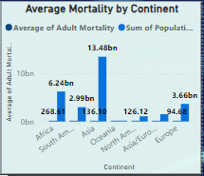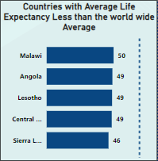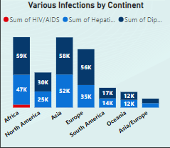It also determines how mortality rates affect life expectancy. The attributes that have an impact on life expectancy are not restricted to this data set so more factors need to be considered for better estimation